CP2406 ASSESSMENT TASK 1 WORKING DOCUMENT

**Problem specification**

The problem is to create a traffic simulator based on Australian traffic traffic rules. This simulator needs to include vehicles(cars, motorbikes, buses), roads and traffic lights. The user can change some settings of the simulator in order to simulate various scenarios.

**Problem decomposition using UML class diagram**

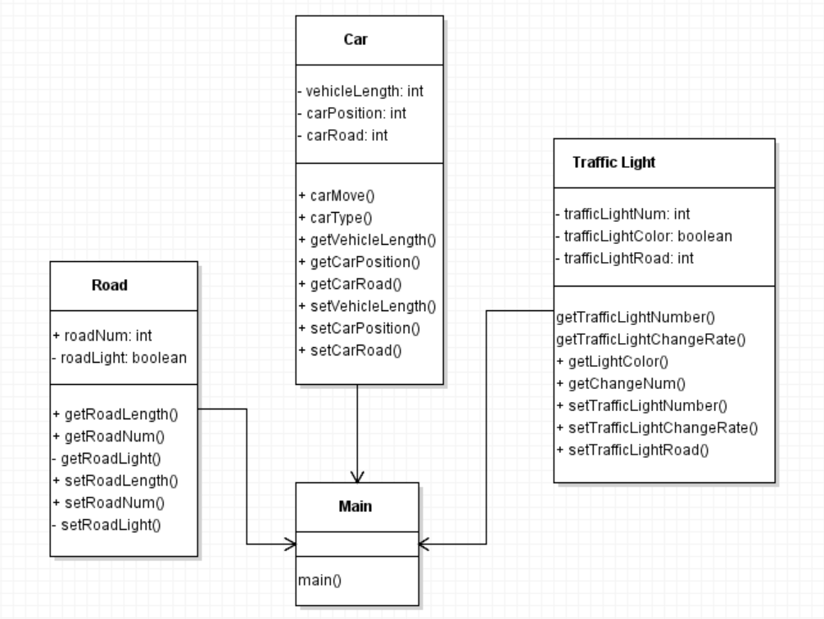

- There are 3 objects will be used which is Car, Road, Traffic Light

**Class Design**

- Main class(public)

Main is a simulator, other objects will be created under the main. Main can control car class, road class and traffic light class. The main class is the role to collect all the classes and let them directly interact to achieve the effect of the simulator.

- Car Class

Private: vehicleLength, carPosition, carRoad

The required attribute for this class are vehicleLength, carPosition and carRoad. The method will be needed for car class are carMove(), carType(), getVehicleLength(), getCarPosition(), getCarRoad(), setVehicleLength(), setCarPosition() and setCarRoad(). It is obvious that onlt two required methods of this class are getter and setter.

- Road class(public)

Private: roadLength, roadNum, roadLight

The required attribute for this class are roadNum and roadLight. The method will be needed foe road class are getRoadLength(), getRoadNum(), getRoadLight(), setRoadLength(), setRoadNum() and setRoadLight().

- Traffic Light(public)

Private: trafficLightNumber, trafficLightRate, trafficLightRoad

The required attribute for traffic light class are light number, light color and light road. The method will be needed for this class are getTrafficLightNumber(), getTrafficLightChangeRate(), getLightColor(), getChangeNum(), setTrafficLightNumber(), setTrafficLightChangeRate() and setTrafficLightRoad().

**Method Design**

The main class method signature will be main()

- main(): initialize the main class

The traffic light class method signature will be getTrafficLightNumber(), getTrafficLightChangeRate(), getLightColor(), getChangeNum(), setTrafficLightNumber(), setTrafficLightChangeRate(), setTrafficLightRoad()

- getTrafficLightNumber(): return the number of the traffic light

- getTrafficLightChangeRate(): return the change rate of the traffic light

- getLightColor(): return the color of the traffic light based on the change rate

- setTrafficLightChangeRate(): set the change rate of the traffic light based on getting a random number and calculate it and change the light

The road class method signature will be getRoadLength(), getRoadNum(), getRoadLight(), setRoadLength(), setRoadNum(), setRoadLight()

- getRoadLength(): return the length of the road

- getRoadNum(): return the current number of the road

- getRoadLight(): return the traffic light value of the road

- setRoadLength(): set the length of the road

- setRoadNum(): set the number of the road

- setRoadLight(): set the traffic light number

The car class method signature will be carMove(), carType(), getVehicleLength(), getCarPosition(), getCarRoad(), setVehicleLength(), setCarPosition(), setCarRoad()

- carMove(): set the position value based on their current value

- getVehicleLength(): return the length of the vehicle

- getCarPosition(): return the current position value

- setVehicleLength(): set the length of the vehicle

- setCarPosition(): set the position of the car